**CS5590 – Big data Analytics and Apps**

**Lab5 Report**

**Submitted by: Gireshbabu, Monuika**

1. We downloaded the game code from the website

<http://www.sourcecodester.com/android/6230/simple-game-android.html?page=1>

The source is then imported into ADT for further development.

The original game is based on “Tap event”

We utilized the punchgesture training from the tutorials and made changes from the code to deliver onPunch gesture.

The original game contains classes

1.Game

2.Gameloop

3.MainActivity

4.Settings

To the above game we have additionally added three of the following classes

1. Connectionservice
2. Sensortagdata
3. Traingesture

The connection service is used to connect the device with sensor and extract values, trainingesture recognizes the data from the sensor and provides the values to the game.

Connectionservice

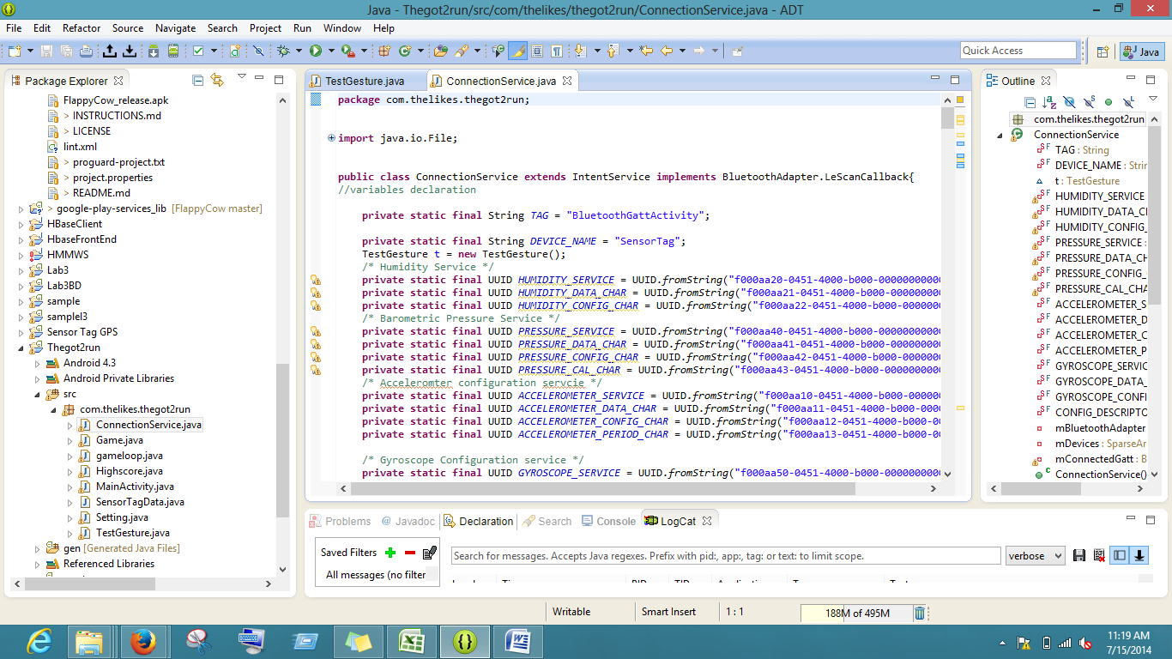

We have to write code for the broadcast listener to catch the broadcast intent In game.java class

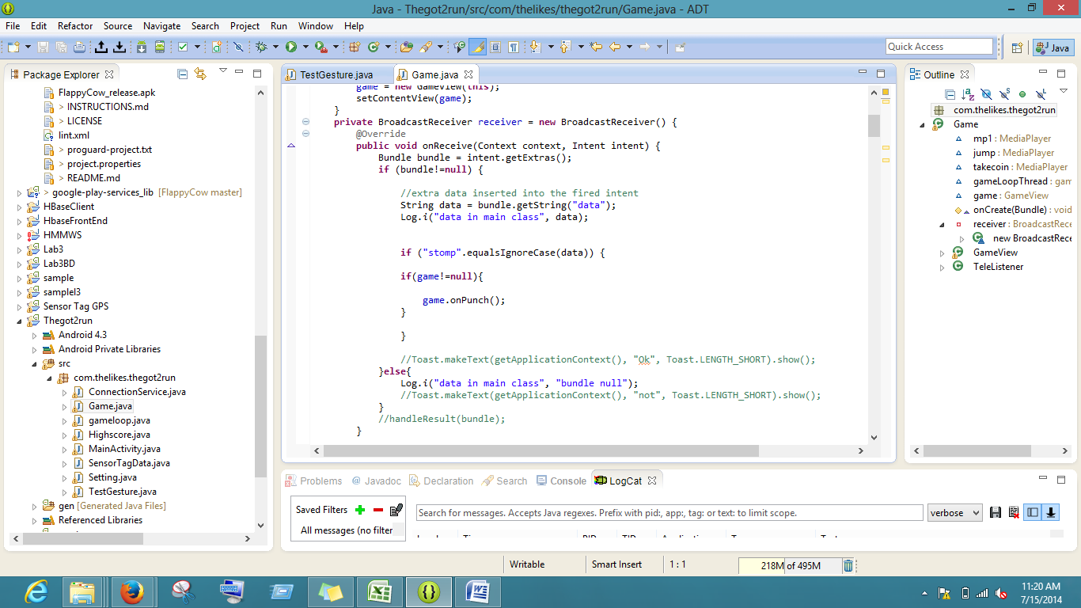

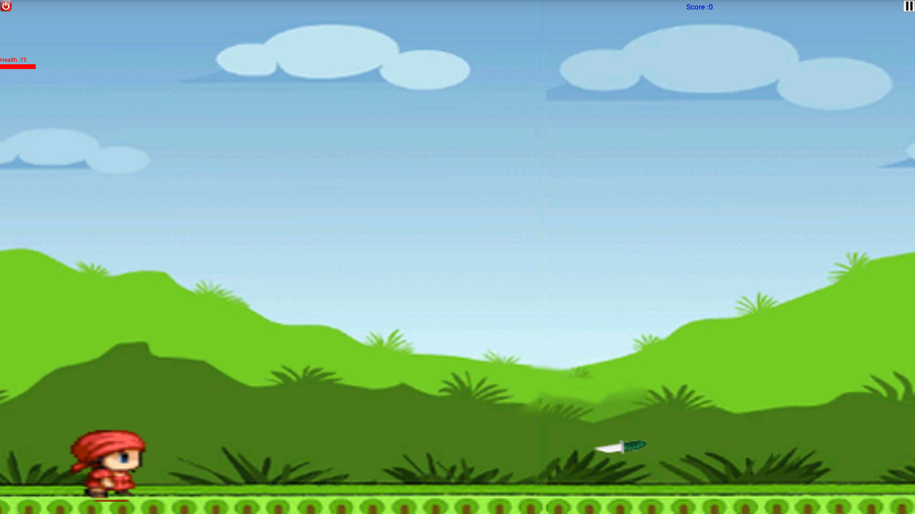

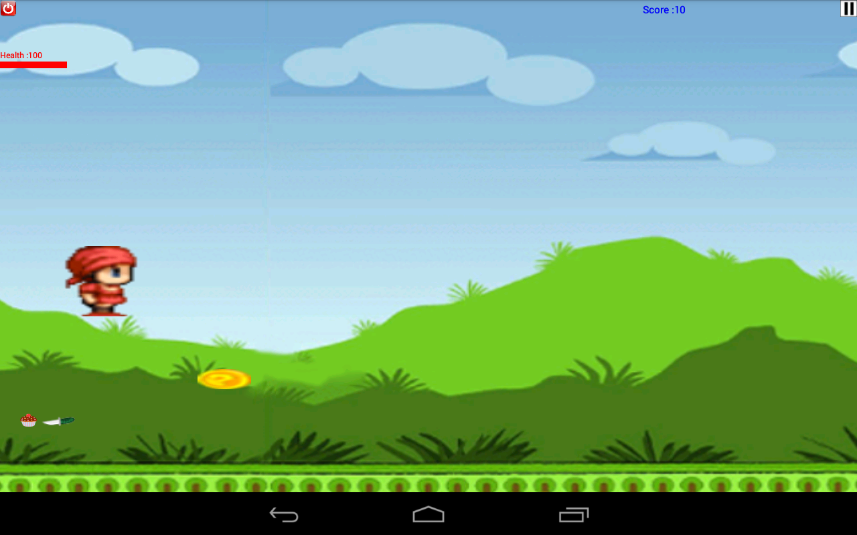

On punch the bitmap image jumps to get protected from the knives and maintain the health.

The source code and sequence files are uploaded to Github.